Like the Seasons, Things Change:
A Comparison of Both Beauty and the Beast movies

Kaylee Billyboy
History 2480
November 22,2017

When one thinks of the story Beauty and the Beast what do they think of? Thoughts like a family movie, a love story or even a fairy tale may come to mind and yes those are all true but is there can be so much more. Essentially the movie is about a girl who falls in love with a Beast who is a prince, and the Beast has to gain the girls trust and love to be able to turn back into a prince. The moral of the story is, if one really loves something let it go and if it is meant to be it will come back. This may be the main message that the author wants everyone to take away from the story in the end, but like many other great pieces of work, this story has so much more to it. When looking at the movie Beauty and the Beast that came out in 1991 one can take away a lot of other messages throughout the movie. Disney has since decided to remake this story into a live version that was released in 2017, not wanting to release the exact movie they made some changes to it. Although it still has the same storyline, the new version has many more deeper views in the movie. Most messages in both movies can be seen from analyzing and comparing the characters. Noticing similarities and differences of the female and male characters can draw out significant messages about gender roles in both movies and also show why Disney used these techniques to embrace their messages and deeper meaning behind them.
Disney is known for its influences on children, that’s why in all movies there is a happy ending and there is usually a moral behind the story teaching kids some life lesson. The story Beauty and the Beast originally stood out as a significant move for the way it portrayed the main female character. Unlike most other movies the main female role isn’t just a girl who relies on her prince to help her live her life as she is hopeless without him. Belle’s character role is significant in feminism as it shows that she can do anything on her own and that she is very independent. Belle is seen as a heroine, which has set her as “an icon and [a} role model… of modern femininity” and it is ideas like this that show “reality” and give “images to live by” therefore making these positive messages set out for those watching. Belle’s character doesn’t change much from the first movie to the second except the story doesn’t focus on her as much, as it is stated the 2017 movie “centralizes the figure of the Beast rather than the heroine, Belle”. Another noted difference is the female characters, like Belle and the girls that are in love with Gaston, have more revealing clothing in the first movie, for instance, more cleavage and a more figure fitting look. This one comes off as surprising as one would think the dress code in 1991 was more appropriate than it is today (2017) as well as it is easy to draw more clothing on. Another thing that was noted was the female characters that are objects in the movie like Ms. Potts, the Duster and the Dresser all seem to play a role of things that one would relate to a female image in older times. These meaning girls have more in common with a dresser because they like to dress up, or dishes or dusting because they are more likely to clean. Does this suggest that that’s what women should do, or did it stay the same to make the plot easy to compare? One last thing that was noticed in the movie was the Duster character, in the first movie is seen as more plump whereas in the new movie she is seen as delicate and dainty. Could be because today that is what the accepted image is, compared to the first one where the bigger size was what was accepted as in 1991. All of these similarities and differences noted above stood out because they have something to say about the way women should be or act, like how they should dress or look and even things that they should do. These each send out a message that this is how a female character should be in that time, as it was noted some things did change which could have been a relation to the time it was produced in. 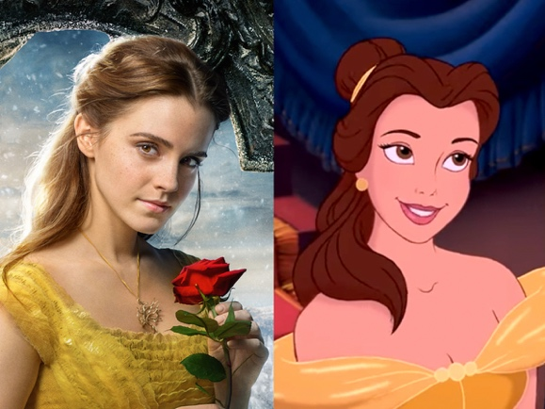 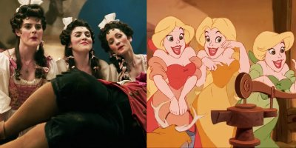
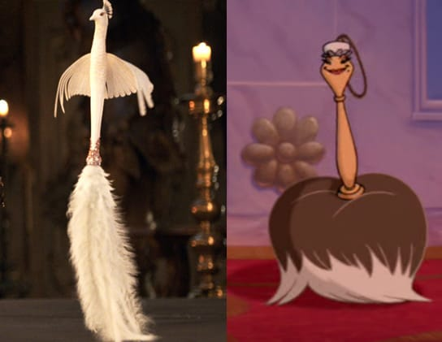
Next to look at are the male figures in the movies. First starting off with the Beast, as stated before the second movie seems to tell a little more about the Beast. Thus making the audience connect more with the Beast by being able to learn his backstory and realizing why he acts the way he does; this is seen as significant because it’s not that often one learns about the prince in the story. It can also be observed that the male characters in the first movie that are a part of the group from the bar seem more aggressive when they don’t believe what Belle says about the Beast and they aggressively lock her up, this could suggest that in that time aggression from men was accepted because it showed masculinity. Something else noticed in the new movie is a scene where the Dresser fights off three men by dressing them as girls, two of them are mortified by it but one is quite happy with his feminine look. In addition to this reference, is that Le Fou in the second movie is “Disney’s first openly gay character”. Showing a gay reference would have never happened in the old movie and even with it being in the new one is quite significant as this shows progression in Disney’s beliefs. Lastly the character Gaston has changed in each movie, for instance, in the old movie Gaston seems to look more strong and muscular but in the new movie he is portrayed as more aggressive. Could one conclude that this is because they want to show that aggression gets more unlike the first movie where just using words wouldn’t work at present times? It seems as in both movies, but mostly the first movie the male “figures [are portrayed] as negative and dangerous characters”, it can only be assumed that this is done to embrace and “present a feminist message while still focusing part of its energies on romantic love” this showing women don’t need to be with men. Although in the second movie this isn’t all true as the Beast is shown to be not as bad as he seems this makings the aggression stand out more. For the most part, the male characters do have significant changes, and it seems the changes are made because of the time the movie was made in.
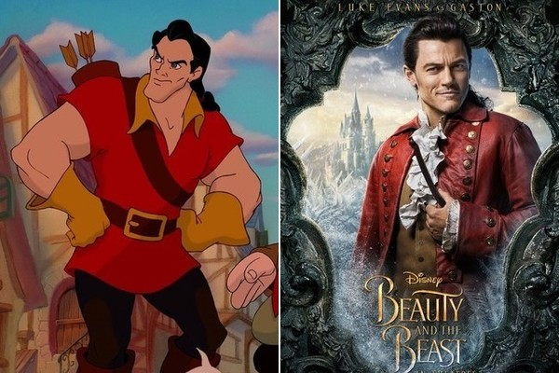
So why does Disney make these changes, and what significance stands behind them? It obvious that some of the changes were made to change the movie, but there is so much more that can be read into it. First one can analyze why the women’s roles have changed. It has been stated that this story is to embrace feminist, so are some of these changes made to get that message across even more. It could be that wardrobe changes were made to make it so the woman’s image shouldn’t be seen in a sexual way by covering up more of the character’s body. With Belle being independent and then the girls having a less revealing wardrobe could be a way of “addressing gender issues”. But there is also the reason why they portray the Duster as slimmer, this could be because the acceptable image of the female body is changing but it is also interesting to notice that when they transform into humans in the new movie she is not seen as a maid like she is in the old movie. This could show that it is no longer acceptable to think of a female image as a maid this embracing the femininity in the movie. All changes in the female roles seem to embrace that girls are so much more than housekeepers or girls that can’t do anything without a man, it shows how much more women can be independent. Then there is the analysis of why the male characters have changed. It has been stated that essentially “Beauty and the Beast is a story about masculinity” with having the “influence of feminism” and making it so Belle “rework[s]… the male roles” by being able to do it herself. So with this being about masculinity, one could assume that is why the male characters are more aggressive in the first movie, to embrace that masculinity. But in the new movie, the characters are softer as the audience gets to know them better, there are references that embrace gay characters. Could this be to show that masculinity isn’t everything for guys and that it is ok for men to feel not a masculine just as much as it is ok for women to want to feel masculine creating that equality between genders in the movies. When really the whole movie is about creating that equality from the first movie to the second, the changes just embrace it that much more whether it be a change in the men or the women.
It seems as if all of the changes are significant in a way that shows how Disney producers have changed over time. Not all changes are a step forward in progression, but many of them are. With changing characters to show that women can be whoever they want and men can too, shows how Disney has accepted the way most of the society thinks today. Changing characters to give that message that it is acceptable for people to be openly gay like La Fou or independent and masculine like Belle is incredible and it just goes to show how one thing that is exactly the same can also change over time. For gender roles are constantly changing and for movie producers to accept that shows this society can change and accept the change and differences there is today. This is how people move on and it is influences like Beauty and the Beast that help people realize difference and change are good. As people in is world need to learn to accept the changes that have been made in movies or life

Bibliography

Alexander, Damian. "Beauty and the Beasts Openly Gay Character is a Poor Tribute." Polygon. Last modified March 17, 2017. https://www.polygon.com/2017/3/17/14948300/beauty-and-the-beast-gay-character-le-fou.

Beauty and the Beast. Directed by Bill Condon. 2017. CA: Walt Disney Studios Motion Picture, 2017. DVD.

Beauty and the Beast. Directed by Gary Trousdale, and Kirk Wise. 1991. NY: Walt Disney Studio Home Entertainment, 1991. VHS.

Cravens, Allison. Fairytale Interrupted: Feminism, Masculinity, Wonder Cinema. New York: Peter Lang, 2016. https://researchonline.jcu.edu.au/47472/1/47472%20Craven%202017.pdf.

Dickens, Faith. "“The Guy with the Problem”: Reform Narrative in Disney's Beauty and the Beast." The University of Central Florida Undergraduate Research Journal5, no. 2 (December 2011), 79-85. https://eds-b-ebscohost-com.ezproxy.tru.ca/eds/pdfviewer/pdfviewer?vid=8&sid=2dddf4ae-5145-4380-b8d6-09c299620186@sessionmgr101.

Disney. Business Insider. 2017. How the new 'Beauty and the Beast' cast compares to the original animated characters. http://www.businessinsider.com/beauty-and-the-beast-cast-compared-original-animated-movie-2017-3/#emma-watson-stars-as-belle-while-her-outfits-differ-slightly-from-the-original-designs-we-think-disney-nailed-belles-overall-look-and-especially-her-hairstyles-1.

Stover, Cassandra. "Damsels and Heroines: The Conundrum of the Post-Feminist Disney Princess." LUX 2, no. 1 (2013), 1-10. doi:10.5642/lux.201301.29.

Beauty and the Beast, directed by Gary Trousdale, and Kirk Wise. (1991; NY: Walt Disney Studio Home Entertainment, 1991), VHS.
Allison Cravens, Fairytale Interrupted: Feminism, Masculinity, Wonder Cinema (New York: Peter Lang, 2016), 9, https://researchonline.jcu.edu.au/47472/1/47472%20Craven%202017.pdf.
Cravens, Fairy-tale Interrupted, 10.
Cravens, Fairy-tale Interrupted, 10.
Beauty and the Beast (1991) and Beauty and the Beast (2017)
Cravens, Fairy-tale Interrupted, Back cover.
Beauty and the Beast (1991)
Beauty and the Beast (1991) and Beauty and the Beast (2017)
Beauty and the Beast (1991) and Beauty and the Beast (2017)
Visual comparison of Belle in each movie. Disney, Business Insider, 2017, http://www.businessinsider.com/beauty-and-the-beast-cast-compared-original-animated-movie-2017-3/#emma-watson-stars-as-belle-while-her-outfits-differ-slightly-from-the-original-designs-we-think-disney-nailed-belles-overall-look-and-especially-her-hairstyles-1.
A visual comparison of the three girls that are in love with Gaston, to see how their clothing compares. Disney, Business Insider, 2017
A visual comparison of the Duster. Disney, Business Insider, 2017
Beauty and the Beast (1991)
Beauty and the Beast (2017)
Damian Alexander, "Beauty and the Beasts Openly Gay Character is a Poor Tribute," Polygon, last modified March 17, 2017, https://www.polygon.com/2017/3/17/14948300/beauty-and-the-beast-gay-character-le-fou.
Beauty and the Beast (1991)
Beauty and the Beast (2017)
Faith Dickens, "“The Guy with the Problem”: Reform Narrative in Disney's Beauty and the Beast," The University of Central Florida Undergraduate Research Journal 5, no. 2 (December 2011): 80, https://eds-b-ebscohost-com.ezproxy.tru.ca/eds/pdfviewer/pdfviewer?vid=8&sid=2dddf4ae-5145-4380-b8d6-09c299620186@sessionmgr101.
Faith Dickens, “The Guy with the Problem”, 80.
Visual Image on how Gaston looks stronger in the first movie. Disney, Business Insider, 2017,
Cassandra Stover, "Damsels and Heroines: The Conundrum of the Post-Feminist Disney Princess," LUX 2, no. 1 (2013): 5, doi:10.5642/lux.201301.29.
Cravens, Fairytale Interrupted, 15.
Cravens, Fairytale Interrupted, 15.
Cravens, Fairytale Interrupted, 15.

